**(Q1)**

**Insertion sort**

**Bubble sort**

**Optimized Bubble sort**

**Selection sort**

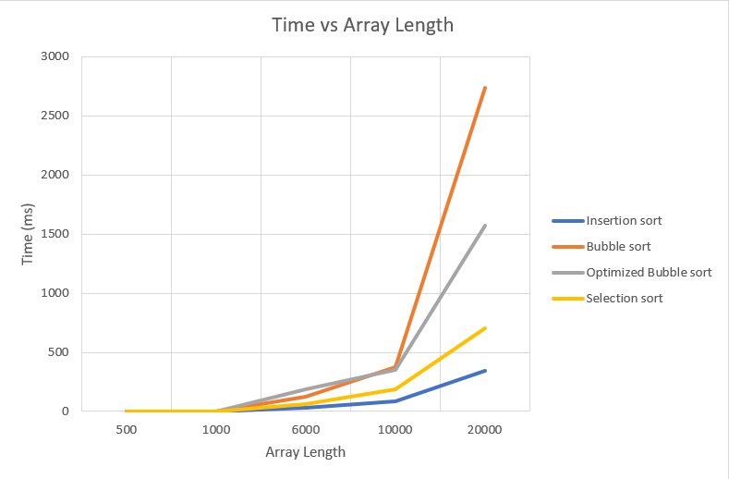

Insertion sort seems to be the fastest way for sorting even at very high lengths.

Second place goes to selection sort, while optimized bubble sort is the third pace where bubble sort seems to be the slowest.

At lover lengths (less than 1000) all sorting algorithms have only take small times which is less than 1ms.